

Requirement & Design Specification

**Global Access Management System (GAMS)**

**Version: 1.0**

– Hanoi, August 2022 –

# Record of Changes

|  |  |  |  |  |
| --- | --- | --- | --- | --- |
| Version | Date | A* M, D | In charge | Change Description |
| V1.0 | 15/2 | A | KienNTHE11 |  |
|  |  |  |  |  |
|  |  |  |  |  |
|  |  |  |  |  |
|  |  |  |  |  |
|  |  |  |  |  |
|  |  |  |  |  |
|  |  |  |  |  |
|  |  |  |  |  |
|  |  |  |  |  |
|  |  |  |  |  |
|  |  |  |  |  |

*A - Added M - Modified D - Deleted

Contents

Record of Changes 2

I. Overview 4

1. User Requirements 4

1.1 Actors 4

1.2 Use Cases 4

2. Overall Functionalities 5

2.1 Screens Flow 5

2.2 Screen Descriptions 5

2.3 Screen Authorization 5

2.4 Non-UI Functions 6

3. System High Level Design 6

3.1 Database Design 6

3.2 Code Packages 7

II. Requirement Specifications 8

1. <<Feature Name>> 8

1.1 <<UseCaseCode_UC Name>> 8

2. Common Functions 11

2.1 UC-2_Login System 11

3. Patron Feature 12

3.1 UC-5_Order a Meal 12

3.2 UC-6_Register for Payroll Deduction 13

III. Design Specifications 14

1. <<Feature Name>> 14

1.1 <<SubFeature Name>> 14

1.2 System Access 15

IV. Appendix 19

1. Assumptions & Dependencies 19

2. Limitations & Exclusions 19

3. Business Rules 19

4. .. 19

# I. Overview

## 1. User Requirements

### 1.1 Actors

|  |  |  |
| --- | --- | --- |
| **#** | **Actor** | **Description** |
| 1 | Admin | Admin manage account (suspension, role assignment, account deletion), catalog management, seller verification, customer report viewing, product moderation, and ad management (approve, reject, delete). |
| 2 | Customer | View, search, purchase products; add to cart; checkout; report sellers; review products; chat with sellers; manage cart and personal information. |
| 3 | Sellers | Manage their products, interact with customers, and process orders. They handle product promotions, track order history, communicate with customers, and access performance reports. Sellers also update their personal profiles as needed. |
| 4 | Shipper | Shipper view orders list, view information of customer and report process to the system. |

### 1.2 Use Cases

#### a. Diagram(s)

#### b. Descriptions

|  |  |  |  |
| --- | --- | --- | --- |
| **ID** | **Feature** | **Use Case** | **Use Case Description** |
| 01 | User Authentication | Login | User can log into the system using email or social media accounts. |
| 02 | User Authentication | Log out | User can safely log out of their accounts. |
| 03 | User Registration | Sign up | New user can create an account by providing basic information. |
| 04 | Password Recovery | Forget Password | User can request a password reset through email or SMS when they forget their password. |
| 05 | Account Management | Change Password | User can change their password through account settings. |
| 06 | Product Discovery | Search Products | User can search for products using keywords, filters, and categories. |
| 07 | Product Discovery | View Product Details | User can view product details such as descriptions, prices, images, and reviews. |
| 08 | Product Management | Manage Categories | Admin can add, edit, or delete product categories. |
| 09 | Account Management | Manage Account | Admin can manage their account information, including email, phone number, and password. |
| 10 | Account Management | Suspend Account | Admin can temporarily suspend a user's account for policy violations. |
| 11 | User Management | Assign Roles | Admin can assign roles such as seller, customers, or admin to users. |
| 12 | Account Management | Delete Account | Admin can delete accounts from the system. |
| 13 | User Management | Verify Sellers | Admin can verify sellers based on legal documents. |
| 14 | Reporting | View Customer Reports | Admin can view reports about user violations or system issues. |
| 15 | Product Management | Moderate Products | Admin can approve, reject, or delete inappropriate products. |
| 16 | Advertisement Management | Accept advertisements | Admin can accept ads from sellers or third parties. |
| 17 | Advertisement Management | Reject advertisements | Admin can reject invalid or inappropriate ads. |
| 18 | Advertisement Management | Delete advertisements | Admin can delete published ads. |
| 19 | Account Management | View profile | User can view their personal profiles. |
| 20 | Account Management | Edit Profile | User can edit personal information such as name, address, and phone number. |
| 21 | E-commerce Transactions | Buy products | Customer can purchase selected products. |
| 22 | Payment Processing | Make payment | Customer can make payments through various methods like credit cards, e-wallets, or bank transfers. |
| 23 | User Interaction | Report seller | Customer can report sellers for violations or dishonest transactions. |
| 24 | Product Interaction | Feedback products | Customer can leave reviews and feedback about purchased products. |
| 25 | User Interaction | Chat between seller and customer | Customer and seller can chat directly about products or orders. |
| 26 | Content Management | View blog | User can view blog posts related to products or market news. |
| 27 | Shopping Cart | Add products to cart | Customer can add products to the cart for later purchase. |
| 28 | Shopping Cart | View cart | Customer can view products added to their shopping cart. |
| 29 | Shopping Cart | Edit Cart | Customer can edit the quantity or remove products from the cart. |
| 30 | Shopping Cart | Delete Cart | Customer can delete the entire cart or individual items from the cart. |
| 31 | Payment Management | Add Card | Customer can add payment cards to their account for transactions. |
| 32 | Product Management | Promote Product | Seller can promote their products through paid ads or promotions. |
| 33 | Order Management | Manage Order of Customers | Seller can manage customer orders, including confirming and processing orders. |
| 34 | Order Management | Orders History | Uses can view the history of their purchased or sold orders. |
| 35 | Order Management | Process Orders | Seller can process orders, including packing and shipping products. |
| 36 | User Interaction | View and respond to feedback | Seller can view and respond to customer feedback about products. |
| 37 | Reporting | View reports and statistics | Seller can view reports and statistics about website and user activity. |

## 2. Overall Functionalities

### 2.1 Screens Flow

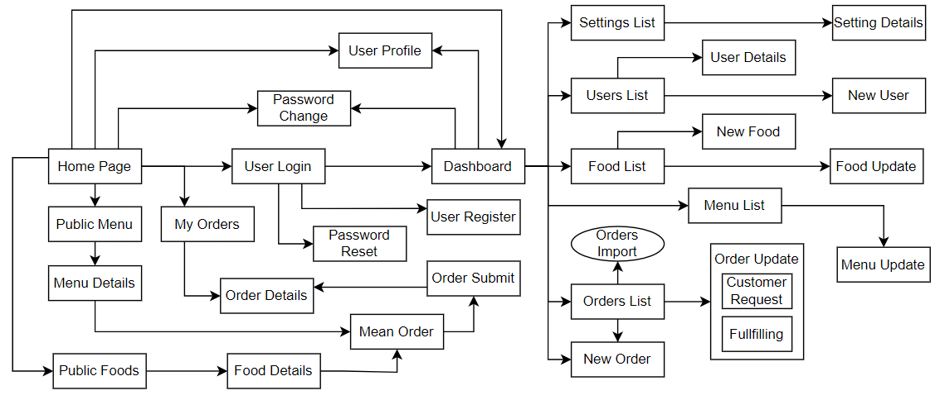

### 2.2 Screen Descriptions

*[Provide the descriptions for the screens in the Screens Flow above]*

|  |  |  |  |
| --- | --- | --- | --- |
| **#** | **Feature** | **Screen** | **Description** |
| 1 | Order Meals | Create Order | <<Screen Brief description>> |
| 2 | Order Meals | Change Order |  |
| 3 | .. |  |  |

### 2.3 Screen Authorization

*[Provide the system roles authorization to the system features (down to screens, and event to the screen activities if applicable) in the table form as below – replace Role1, Role2,… with your specific system user role names]*

|  |  |  |  |  |
| --- | --- | --- | --- | --- |
| **Screen** | **Role-Name1** | **Role-Name2** | **Role-Name3** | **…** |
| <<Screen Name1>> | X |  | X | X |
| <<Screen Activity>> |  |  | X | X |
| <<Screen Name2>> | X |  | X |  |
| Query All Data | X |  |  |  |
| Query Own Data |  |  | X |  |
| Query Managed Data |  |  | X |  |
| Add New Data |  |  | X | X |
| Update All Data |  |  |  | X |
| Update Own Data |  |  |  | X |
| Update Managed Data |  |  |  | X |
| Delete Data |  |  |  |  |
| … |  |  |  |  |

### 2.4 Non-UI Functions

*[Provide the descriptions for the functions which have no UI (or not screens), i.e batch/cron job, service, API, etc.]*

|  |  |  |  |
| --- | --- | --- | --- |
| **#** | **Feature** | **System Function** | **Description** |
| 1 | <<Feature Name>> | <<Function Name1>> | <<Function Name1 Description>> |
| 2 | … |  |  |

## 3. System High Level Design

### 3.1 Database Design

*[Provide the tables relationship like example below]*

#### a. Database Schema



#### b. Table Descriptions

|  |  |  |  |
| --- | --- | --- | --- |
| ***No*** | ***Table*** | ***Fields*** | ***Description*** |
| 01 | Account | id INT PRIMARY KEY IDENTITY(1,1),  username NVARCHAR(100) NOT NULL,  password NVARCHAR(255) NOT NULL,  email NVARCHAR(255) NOT NULL,  phone NVARCHAR(20),  address NVARCHAR(255),  roleID INT, -- Foreign key to Role table  status NVARCHAR(50),  CONSTRAINT FK_Account_Role FOREIGN KEY (roleID) REFERENCES Role(ID) | Stores login credentials and role information for users. |
| 02 | Product | id INT PRIMARY KEY IDENTITY(1,1),  name NVARCHAR(100) NOT NULL,  img NVARCHAR(255),  price DECIMAL(10, 2) NOT NULL,  title NVARCHAR(255),  description NVARCHAR(MAX),  cateID INT, -- Foreign key to Category table  sellID INT, -- Seller ID, possibly linked to the Account table  brand_id INT, -- Foreign key to Brand table  CONSTRAINT FK_Product_Category FOREIGN KEY (cateID) REFERENCES Category(cid),  CONSTRAINT FK_Product_Brand FOREIGN KEY (brand_id) REFERENCES Brand(brand_id) | Stores product details, linking to both brand and category. |
| 03 | Category | cid INT PRIMARY KEY IDENTITY(1,1),  cname NVARCHAR(100) NOT NULL | Stores categories for the products |
| 04 | Brand | brand_id INT PRIMARY KEY IDENTITY(1,1),  brandName NVARCHAR(100) NOT NULL | Stores information about product brands. |
| 05 | Role | ID INT PRIMARY KEY IDENTITY(1,1),  roleName NVARCHAR(100) NOT NULL | Defines roles for users |
| 06 | Cart | AccountID INT, -- Foreign key to Account table  ProductID INT, -- Foreign key to Product table  Amount INT NOT NULL,  CONSTRAINT FK_Cart_Account FOREIGN KEY (AccountID) REFERENCES Account(id),  CONSTRAINT FK_Cart_Product FOREIGN KEY (ProductID) REFERENCES Product(id) | A temporary storage for products that a user intends to buy, linking products and accounts |
| 07 | Orders | id INT PRIMARY KEY IDENTITY(1,1),  accountID INT, -- Foreign key to Account table  totalPrice DECIMAL(10, 2),  note NVARCHAR(255),  create_date DATE NOT NULL,  shipping_ID INT, -- Foreign key to Shipping table CONSTRAINT FK_Orders_Account FOREIGN KEY (accountID) REFERENCES Account(id),  CONSTRAINT FK_Orders_Shipping FOREIGN KEY (shipping_ID) REFERENCES Shipping(id) | Represents an order made by a user, including a link to shipping. |
| 08 | OrderDetail | id INT PRIMARY KEY IDENTITY(1,1),  order_id INT, -- Foreign key to Orders table  productName NVARCHAR(100) NOT NULL,  productImage NVARCHAR(255),  productPrice DECIMAL(10, 2) NOT NULL,  quantity INT NOT NULL,  CONSTRAINT FK_OrderDetail_Orders FOREIGN KEY (order_id) REFERENCES Orders(id) | Provides details of each product within an order |
| 09 | Shipping | id INT PRIMARY KEY IDENTITY(1,1),  name NVARCHAR(100) NOT NULL,  phone NVARCHAR(20),  address NVARCHAR(255),  status NVARCHAR(50) | Stores information about shipping addresses and statuses. |
| 10 | Payment | Payment_id INT PRIMARY KEY IDENTITY(1,1),  OrderID INT, -- Foreign key to Orders table  Payment_date DATE NOT NULL,  Amount DECIMAL(10, 2) NOT NULL,  PaymentMethod NVARCHAR(50),  Status NVARCHAR(50),  CONSTRAINT FK_Payments_Orders FOREIGN KEY (OrderID) REFERENCES Orders(id) | Records payment details, linking to orders. |

### 3.2 Code Packages

*[Provide the package diagram for each sub-system. The content of this section including the overall package diagram, the explanation, package and class naming conventions in each package. Please see the sample & description table format below]*

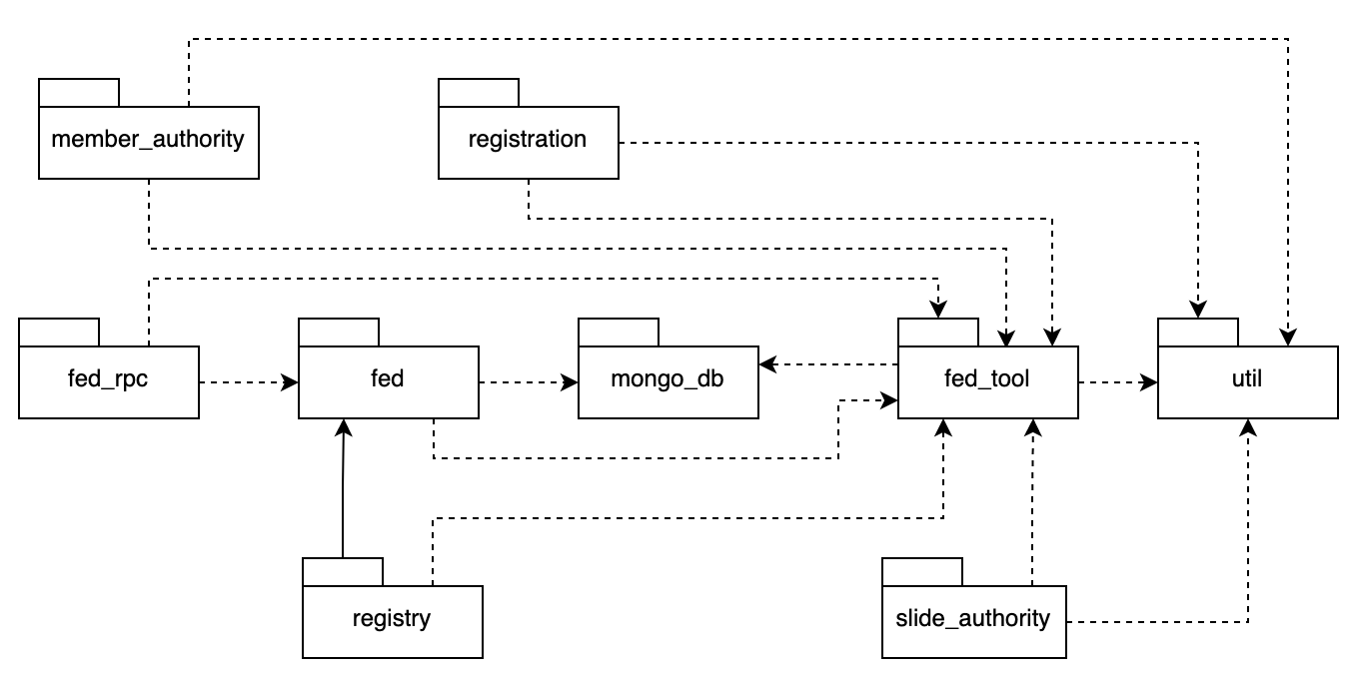

***Package descriptions***

|  |  |  |
| --- | --- | --- |
| **No** | **Package** | **Description** |
| *01* | *Member_authority* | *<Description of the package>* |
| *02* | *registration* | *<Description of the package>* |
| *03* | *…* |  |

# II. Requirement Specifications

## 1. <<Feature Name>>

### 1.1 <<UseCaseCode_UC Name>>

#### a. Functionalities

Provide the functional description for the use cases using the template/guides below

**Functional Description Template**

|  |  |  |  |
| --- | --- | --- | --- |
| UC ID and Name: |  | | |
| Created By: |  | Date Created: |  |
| Primary Actor: |  | Secondary Actors: |  |
| Trigger: |  | | |
| Description: |  | | |
| Preconditions: |  | | |
| Postconditions: |  | | |
| Normal Flow: |  | | |
| Alternative Flows: |  | | |
| Exceptions: |  | | |
| Priority: | High (Medium, Low), Must Have (Should Have, Could Have),.. | | |
| Frequency of Use: |  | | |
| Business Rules: |  | | |
| Other Information: |  | | |
| Assumptions: |  | | |

**Functional Description Contents**

***Use Case ID and Name***

Give each use case a unique integer sequence number identifier. State a concise name for the use case that indicates the value the use case would provide to some user. Begin with an action verb, followed by an object.

***Author and Date Created***

Enter the name of the person who initially wrote this use case and the date it was written.

***Primary and Secondary Actors***

An actor is a person or other entity external to the software system being specified who interacts with the system and performs use cases to accomplish tasks. Different actors often correspond to different user classes, or roles, identified from the customer community that will use the product. Name the primary actor that will be initiating this use case and any other secondary actors who will participate in completing execution of the use case.

***Trigger***

Identify the business event, system event, or user action that initiates the use case. This trigger alerts the system that it should begin testing the preconditions for the use case so it can judge whether to proceed with execution.

***Description***

Provide a brief description of the reason for and outcome of this use case, or a high-level description of the sequence of actions and the outcome of executing the use case.

***Preconditions***

List any activities that must take place, or any conditions that must be true, before the use case can be started. The system must be able to test each precondition. Number each precondition. Example: PRE-1: User’s identity has been authenticated.

***Postconditions***

Describe the state of the system at the successful conclusion of the use case execution. Label each postcondition in the form POST-X, where X is a sequence number. Example: POST-1: Price of item in the database has been updated with the new value.

***Normal Flow***

Provide a description of the user actions and corresponding system responses that will take place during execution of the use case under normal, expected conditions. This dialog sequence will ultimately lead to accomplishing the goal stated in the use case name and description. Show a numbered list of actions performed by the actor, alternating with responses provided by the system. The normal flow is numbered “X.0”, where “X” is the Use Case ID.

***Alternative Flows***

Document other successful usage scenarios that can take place within this use case. State the alternative flow, and describe any differences in the sequence of steps that take place. Number each alternative flow in the form “X.Y”, where “X” is the Use Case ID and Y is a sequence number for the alternative flow. For example, “5.3” would indicate the third alternative flow for use case number 5. Indicate where each alternative flow would branch off from the normal flow, and if pertinent, where it would rejoin the normal flow.

***Exceptions***

Describe any anticipated error conditions that could occur during execution of the use case and how the system is to respond to those conditions. Number each alternative flow in the form “X.Y.EZ”, where “X” is the Use Case ID, Y indicates the normal (0) or alternative (>0) flow during which this exception could take place, “E” indicates an exception, and “Z” is a sequence number for the exceptions. For example “5.0.E2” would indicate the second exception for the normal flow for use case number 5. Indicate where in the normal (or an alternative) flow each exception could occur.

***Priority***

Indicate the relative priority of implementing the functionality required to allow this use case to be executed. Use the same priority scheme as that used for the functional requirements.

***Frequency of Use***

Estimate the number of times this use case will be performed per some appropriate unit of time. This gives an early indicator of throughput, concurrent usage loads, and transaction capacity.

***Business Rules***

List any business rules that influence this use case. Don’t include the business rule text here, just its identifier so the reader can find it in another repository when needed.

***Other Information***

Identify any additional requirements, such as quality attributes, for the use case that may need to be addressed during design or implementation. Also list any associated functional requirements that aren’t a direct part of the use case flows but which a developer needs to know about. Describe what should happen if the use case execution fails for some unanticipated or systemic reason (e.g., loss of network connectivity, timeout). If the use case results in a durable state change in a database or the outside world, state whether the change is rolled back, completed correctly, partially completed with a known state, or left in an undetermined state as a result of the exception.

***Assumptions***

List any assumptions that were made regarding this use case or how it might execute.

#### b. Business Rules

Provide the business rules those are applied only to the use case

|  |  |  |
| --- | --- | --- |
| **ID** | **Business Rule** | **Business Rule Description** |
| FR1 | Password Encoding | User’s password must be encoded with MD5 hashing |

## 2. Common Functions

### 2.1 UC-2_Login System

#### a. Functional Description

|  |  |  |  |
| --- | --- | --- | --- |
| UC ID and Name: | **UC-2_Login System** | | |
| Created By: | MinhNNT | Date Created: | 16/Jun/2023 |
| Primary Actor: | Customer | Secondary Actors: | None |
| Trigger: | User clicks Login button from the page header, or  User accesses an authenticated feature (from a link or type the page URL directly into the address bar) | | |
| Description: | As a user, I want to be able to log into the system so that I can use the system’s authenticated features and access my personalized account. | | |
| Preconditions: | User account has been created & authorized | | |
| Postconditions: | * User logs in the system successfully * The system tracked successful login into the Activity Log | | |
| Normal Flow | **2.0 Login System**  1. User accesses the User Login screen  2. User types in the login details or choo other login options (see 2.1 and 2.2)  3. User clicks the Login button  4. System validates the login details (see 2.0.E1)  5. System allows user to access  6. System tracks user’s success login to the Activity Log  7. System accesses the Home Page (or the previous calling page if any) | | |
| Alternative Flows: | ***2.1 Google Login***  1. User chooses to login system using Google account  2. System redirects the user to the Google’s Login screen  3. User types in the Google account details and chooses to login  4. Google validates user’s login information successfully and redirect him/her back to the system  5. Return to step 5 of normal flow.  ***2.2 Facebook Login***  1. User chooses to login system using Facebook account  2. System redirects the user to the Facebook’s Login screen  3. User types in the Facebook account details and chooses to login  4. Facebook validates user’s login information successfully and redirect him/her back to the system  5. Return to step 5 of normal flow. | | |
| Exceptions: | ***2.0.E1 System can’t authenticate the user***  1. The Error Message screen is shown to the user  2. User cancels the logging in *=> UC stops, change to UC-1_View Home Page*  3. User clicks “Forgot Password?” link *=> change to UC-3_Reset Password*  4. User clicks “Register” link *=> change to UC-4_Register User Account* | | |
| Priority: | Must Have | | |
| Frequency of Use: |  | | |
| Business Rules: | FR1, FR2, FR3 | | |
| Other Information: |  | | |
| Assumptions: |  | | |

#### b. Business Rules

|  |  |  |
| --- | --- | --- |
| **ID** | **Business Rule** | **Business Rule Description** |
| FR1 | Password Encoding | User’s password must be encoded with MD5 hashing |
| FR2 | Invalid Logging In | User can’t be authenticated to login the system if below cases   * His/her logging-in details are incorrect * His/her account has not been verified * His/her account has been locked or blocked |
| FR3 | Account Locking | If user inputs wrong logging-in details 6 times continuously, his/her account would be locked in 30 minutes |

## 3. Patron Feature

### 3.1 UC-5_Order a Meal

#### a. Functional Description

|  |  |  |  |
| --- | --- | --- | --- |
| ID and Name: | **UC-5 Order a Meal** | | |
| Created By: | Prithvi Raj | Date Created: | 10/4/13 |
| Primary Actor: | Patron | Secondary Actors: | Cafeteria Inventory System |
| Description: | A Patron accesses the Cafeteria Ordering System from the corporate intranet or from home, views the menu for a specific date if desired, selects food items, and places an order for a meal to be delivered to a specified location within a specified 15-minute time window. | | |
| Trigger: | A Patron indicates that he wants to order a meal | | |
| Preconditions: | PRE-1. Patron is logged into COS.  PRE-2. Patron is registered for meal payments by payroll deduction. | | |
| Postconditions: | POST-1. Meal order is stored in COS with a status of “Accepted”.  POST-2. Inventory of available food items is updated to reflect items in this order.  POST-3. Remaining delivery capacity for the requested time window is updated. | | |
| Normal Flow: | **5.0 Order a Single Meal**   1. Patron asks to view menu for a specific date. (see 5.0.E1, 5.0.E2) 2. COS displays menu of available food items and the daily special. 3. Patron selects one or more food items from menu. (see 5.1) 4. Patron indicates that meal order is complete. (see 5.2) 5. COS displays ordered menu items, individual prices, and total price, including taxes and delivery charge. 6. Patron either confirms meal order (continue normal flow) or requests to modify meal order (return to step 2). 7. COS displays available delivery times for the delivery date. 8. Patron selects a delivery time and specifies the delivery location. 9. Patron specifies payment method. 10. COS confirms acceptance of the order. 11. COS sends Patron an email message confirming order details, price, and delivery instructions. 12. COS stores order, sends food item information to Cafeteria Inventory System, and updates available delivery times. | | |
| Alternative Flows: | **5.1 Order multiple identical meals**   1. Patron requests a specified number of identical meals. (see 5.1.E1) 2. Return to step 4 of normal flow.   **5.2 Order multiple meals**   1. Patron asks to order another meal. 2. Return to step 1 of normal flow. | | |
| Exceptions: | **5.0.E1 Requested date is today and current time is after today’s order cutoff time**  1. COS informs Patron that it’s too late to place an order for today.  2a. If Patron cancels the meal ordering process, then COS terminates use case.  2b. Else if Patron requests another date, then COS restarts use case.  **5.0.E2 No delivery times left**  1. COS informs Patron that no delivery times are available for the meal date.  2a. If Patron cancels the meal ordering process, then COS terminates use case.  2b. Else if Patron requests to pick the order up at the cafeteria, then continue with normal flow, but skip steps 7 and 8.  **5.1.E1 Insufficient inventory to fulfill multiple meal order**  1. COS informs Patron of the maximum number of identical meals he can order, based on current available inventory.  2a. If Patron modifies number of meals ordered, then Return to step 4 of normal flow.  2b. Else if Patron cancels the meal ordering process, then COS terminates use case. | | |
| Priority: | High | | |
| Frequency of Use: | Approximately 300 users, average of one usage per day. Peak usage load for this use case is between 9:00 A.M. and 10:00 A.M. local time. | | |
| Business Rules: | BR-1, BR-2, BR-3, BR-4, BR-11, BR-12, BR-33 | | |
| Other Information: | 1. Patron shall be able to cancel the meal ordering process at any time prior to confirming it. 2. Patron shall be able to view all meals he ordered within the previous six months and repeat one of those meals as the new order, provided that all food items are available on the menu for the requested delivery date. (Priority = M) 3. The default date is the current date if the Patron is using the system before today’s order cutoff time. Otherwise, the default date is the next day that the cafeteria is open. | | |
| Assumptions: | Assume that 15 percent of Patrons will order the daily special (source: previous 6 months of cafeteria data). | | |

#### b. Business Rules

None

### 3.2 UC-6_Register for Payroll Deduction

#### a. Functional Description

|  |  |  |  |
| --- | --- | --- | --- |
| ID and Name: | **UC-6 Register for Payroll Deduction** | | |
| Created By: | Nancy Anderson | Date Created: | 9/15/13 |
| Primary Actor: | Patron | Secondary Actors: | Payroll System |
| Description: | Cafeteria patrons who use the COS and have meals delivered must be registered for payroll deduction. For noncash purchases made through the COS, the cafeteria will issue a payment request to the Payroll System, which will deduct the meal costs from the next scheduled employee payday direct deposit. | | |
| Trigger: | Patron requests to register for payroll deduction, or Patron says yes when COS asks if he wants to register | | |
| Preconditions: | PRE-1. Patron is logged into COS. | | |
| Postconditions: | POST-2. Patron is registered for payroll deduction. | | |
| Normal Flow: | **6.0 Register for Payroll Deduction**   1. COS asks Payroll System if Patron is eligible to register for payroll deduction. 2. Payroll System confirms that Patron is eligible to register for payroll deduction. 3. COS asks Patron to confirm his desire to register for payroll deduction. 4. If so, COS asks Payroll System to establish payroll deduction for Patron. 5. Payroll System confirms that payroll deduction is established. 6. COS informs Patron that payroll deduction is established. | | |
| Alternative Flows: | None | | |
| Exceptions: | 6.0.E1 Patron is not eligible for payroll deduction  6.0.E2 Patron is already enrolled for payroll deduction | | |
| Priority: | High | | |
| Business Rules: | BR-86 and BR-88 govern an employee’s eligibility to enroll for payroll deduction. | | |
| Other Information: | Expect high frequency of executing this use case within first 2 weeks after system is released. | | |

#### b. Business Rules

None

# III. Design Specifications

## 1. <<Feature Name>>

### 1.1 <<SubFeature Name>>

#### a. <<Screen/Function Name>>

*[Provide brief description of the screen/function + related UC here and other details as in the sub-sections]*

##### UI Design

*[This is to describe the UI layout (Mockup prototype) & descriptions for screen fields/components]*

<<Mockup prototype>>

|  |  |  |
| --- | --- | --- |
| **Field Name** | **Field Type** | **Description** |
| ***Field Group Name*** | | |
| <<Field-Name>> | <<Field type>> | <<Field description & data initializing design>> |

##### Database Access

*[Provide the design description for the screen/function to access the database here: what table the screen/function would access, which transactions does it make (C-Create, R-Read, U-Update, or D-Delete), and how/purpose of the access (by providing Description and SQL commands)]*

|  |  |  |
| --- | --- | --- |
| **Table** | **CRUD** | **Description** |
| <<Table Name>> | <<transaction(s)>> | <<Table access description: purpose, how,…>> |
| .. |  |  |

***SQL Commands***

*[Provide the detailed SQL (select, insert, update...) which are used in implementing the screen/function]*

### 1.2 System Access

#### a. User Login

This screen allows user to be authenticated to the system screens/functionalities.

Related use cases:

* UC02_Login System

##### UI Design

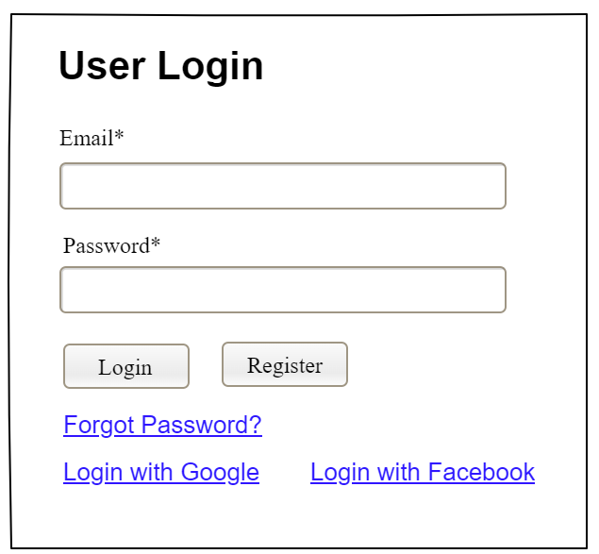

|  |  |  |
| --- | --- | --- |
| **Field Name** | **Field Type** | **Description** |
| Email* | Text Box | This is for user to input valid email address for logging in |
| Password* | Password Box | This is for user to input password for logging in |
| Login | Button | User clicks to authenticate him/herself into the system with provided email & password |
| Register | Button | User clicks to redirect to the User Register page for registering new user account to access the system |
| Forgot Password? | Hyperlink | User clicks to redirect to the Password Reset page for resetting his/her forgot password |
| Login with Google | Hyperlink | Allow user to login with his/her Google account |
| Login with Facebook | Hyperlink | Allow user to login with his/her Facebook account |

##### Database Access

|  |  |  |
| --- | --- | --- |
| **Table** | **CRUD** | **Description** |
| User | R | Verify UserName & Password information |
| Setting, User | R | Specify the authorizations of the logged-in user |

***SQL Commands:***

1/ Verify UserName & Password information

SELECT user_id, full_name, email, image_url, status

FROM user WHERE user_name = ? AND password = ?

2/ Specify the authorizations of the logged-in user

SELECT mapped_values FROM setting WHERE setting_id = ?

SELECT setting_name, mapped_values FROM setting WHERE setting_id IN (?)

#### b. Setting List

##### UI Design

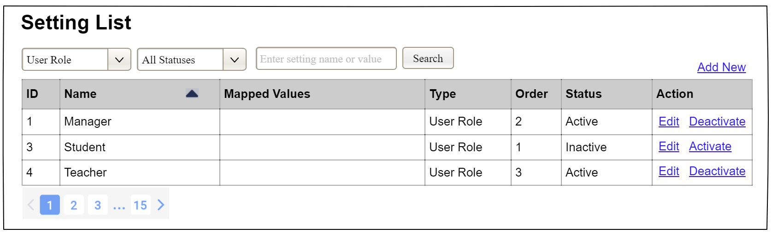

|  |  |  |
| --- | --- | --- |
| **Field Name** | **Field Type** | **Description** |
| ***Search Fields*** | | |
| Setting Type | Combo Box  Single-Choice | Filled with the list of current active setting types  Allow to filter the list by setting type;  Default value is “All Types” |
| Setting Status | Combo Box  Single-Choice | Values: All Statuses (default), Active, and Inactive  Allow to filter the list by status  Default value: “All Statuses” |
| Search Phase | Text Box  String (30) | Allow to search using the name or map values  Default value: blank |
| Search | Button | Click to refresh the list with the defined filter(s) and search phrase. |
| Add New | Hyperlink | Click to open the Setting Details page for adding new setting (master data) |
| ***Data Table*** | | |
| ID | Integer | Auto-increased identifier of the setting |
| Name | Text | Name of the setting |
| Mapped Values | Text | Supplementary information for the setting |
| Type | Text | Type of the setting |
| Order | Integer | Display order of the setting: the order of the setting type, displayed among the list of settings with the same type |
| ***Data Actions*** | | |
| Edit | icon | Click to open the Setting Details page for updating the relevant setting (master data) |
| Activate | icon | Shown when the data status is inactive. This is to activate the relevant setting (master data) |
| Deactivate | Ion | Shown when the data status is active. This is to deactivate the relevant setting (master data) |

##### Database Access

|  |  |  |
| --- | --- | --- |
| **Table** | **CRUD** | **Description** |
| Setting | RU | Query the list of current settings from the database  Update status of a specific setting |

***SQL Commands:***

1/ Query the list of current settings from the database

SELECT setting_id, setting_name, mapped_values, type_id, display_order, status

FROM setting WHERE (setting_type = ?) AND (status = ?) AND (setting_name LIKE ?)

2/ Update status of a specific setting

UPDATE setting SET status = ? WHERE setting_id = ?

#### c. Setting Details

##### UI Design

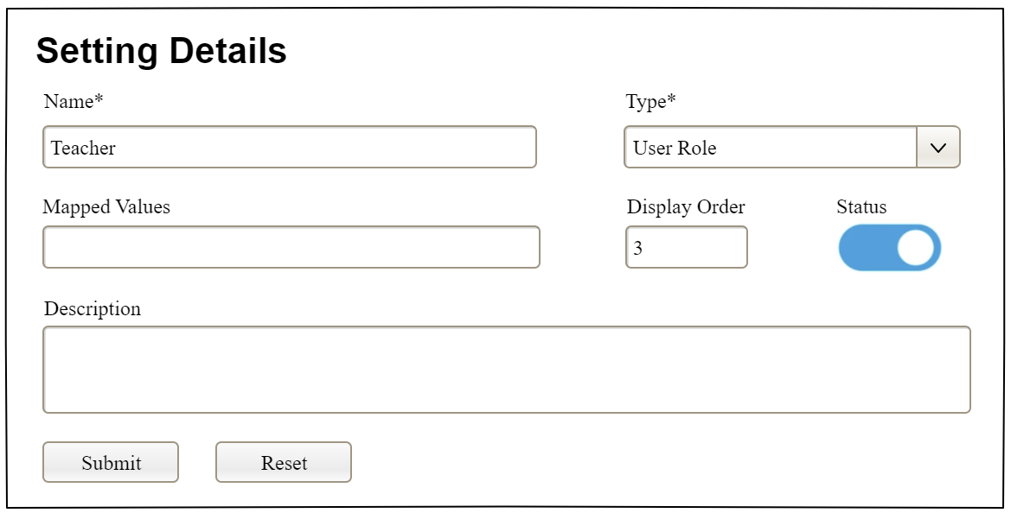

|  |  |  |
| --- | --- | --- |
| **Field Name** | **Field Type** | **Description** |
| Name* | Text Box  String (20) | Name of the setting |
| Type* | Combo Box  (Single Choice) | Type of the setting, filled with the list of setting types  Default value: the first type in the list |
| Mapped Values | Text Box  String (50) | Supplementary information for the setting (if any) |
| Order | Text Box  Integer (>=0) | Display order of the setting: the order of the setting type, displayed among the list of settings with the same type |
| Status | On/Off button | Status of the setting: Active or Inactive  Default value: Active |
| Description | Text Area  String (200) | Description of the setting |
| Submit | Button | Click to store new or updated setting details |
| Reset | Button | Click to reset the changes use has made on the screen fields back to the initial values when the screen is loaded |

##### Database Access

…

# IV. Appendix



## 1. Assumptions & Dependencies

*[Record any assumptions that were made when conceiving the project and writing this vision and scope document. Note any major dependencies the project must rely upon for success, such as specific technologies, third-party vendors, development partners, or other business relationships.]*

<<Sample:

AS-1: Systems with appropriate user interfaces will be available for cafeteria employees to process the expected volume of meals ordered.

AS-2: Cafeteria staff and vehicles will be available to deliver all meals for specified delivery time slots within 15 minutes of the requested delivery time.

DE-1: If a restaurant has its own on-line ordering system, the Cafeteria Ordering System must be able to communicate with it bi-directionally.

>>

## 2. Limitations & Exclusions

*[Identify any product features or characteristics that a stakeholder might anticipate, but which are not planned to be included in the new product]*

## 3. Business Rules

*[Provide common business rules that you must follow. The information can be provided in the table format as the sample below]*

<<Sample

|  |  |  |
| --- | --- | --- |
| **ID** | **Category** | **Rule Definition** |
| BR-01 | Constraints | Delivery time windows are 15 minutes, beginning on each quarter hour. |
| BR-02 | Constraints | Deliveries must be completed between 10:00 A.M. and 2:00 P.M. local time, inclusive. |
| BR-03 | Facts | All meals in a single order must be delivered to the same location. |
| BR-04 | Facts | All meals in a single order must be paid for by using the same payment method. |
| BR-11 | Constraints | If an order is to be delivered, the patron must pay by payroll deduction. |
| BR-12 | Computations | Order price is calculated as the sum of each food item price times the quantity of that food item ordered, plus applicable sales tax, plus a delivery charge if a meal is delivered outside the free delivery zone. |
|  |  |  |

>>

## 4. ..